BIOL 207 –Group Assignment Units C & D – (20 Points)

- You are observing the progress of a 2n = 6 cell through meiosis. One homologous chromosome pair is homozygous for the allele sn; another homologous pair is heterozygous for the alleles Pm and pm; while a third homologous pair is homozygous for the allele W.

- Draw a diagram of the single nucleus at metaphase I. Indicate the ploidy (with chromosome number) and DNA content at this stage. Make sure you clearly label the alleles on all chromosomes. 4 marks.
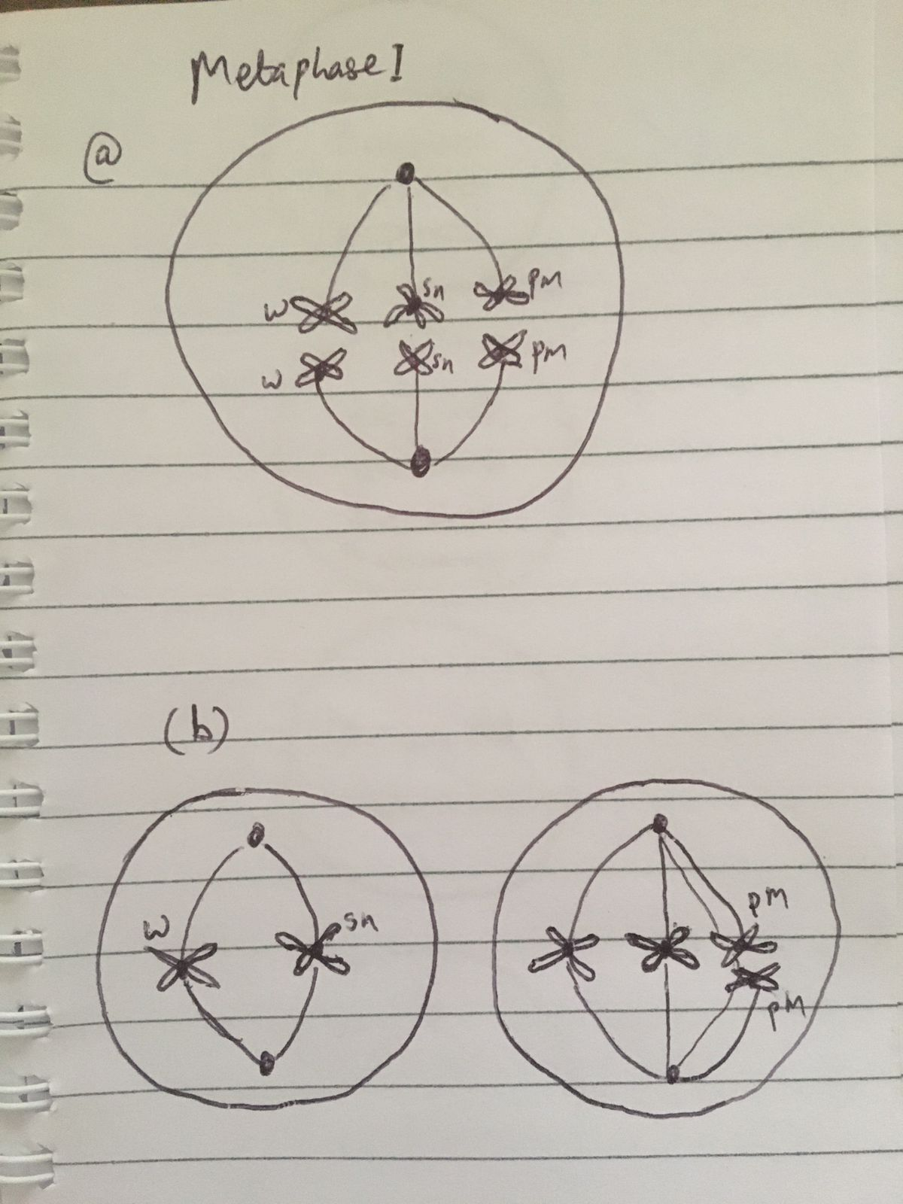
In anaphase I, nondisjunction occurs involving the chromosome pair that is heterozygous for the alleles Pm and pm.

- Draw a diagram of the two nuclei (secondary meiocytes) at metaphase II. Make sure you clearly label the alleles on all chromosomes. 2 marks.
- Draw all of the potential meiotic products that would result from this meiosis. Make sure you clearly label the alleles on all chromosomes. Indicate the ploidy (with chromosome number) for each of the meiotic products. 4 marks.
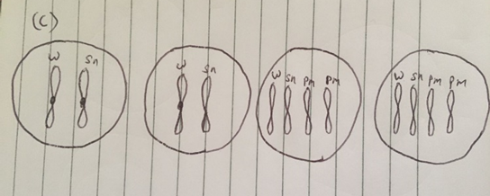

2. Siderophores are small, high-affinity iron-chelating compounds secreted by microorganisms such as bacteria and fungi to scavenge necessary iron from their environment. The environmentally scavenged iron can be assimilated (taken up) from the environment and used for cellular processes. You are interested in the biochemical pathway responsible for the siderophore biosynthesis, coprogen B, which plays a role in iron assimilation in the fungal pathogen Talaromyces marneffei, which is endemic to Southeast Asia. The pathway leading to the biosynthesis of coprogen B includes the following precursors:

anhydromevalonyl-hydroxyornithine
mevalonate
andromevalonyl-CoA
hydroxyornithine
mevalonyl-CoA
ornithine

- Using the information above, find a primary research article that will confirm the order of the six precursors, in the pathway leading to coprogen B, in one of its figures. Copy and paste the figure image here and include a full citation (below it to credit where you found it (list authors, year, the title of paper, title of journal - format doesn't matter as long as all of the information is provided). 2 marks.

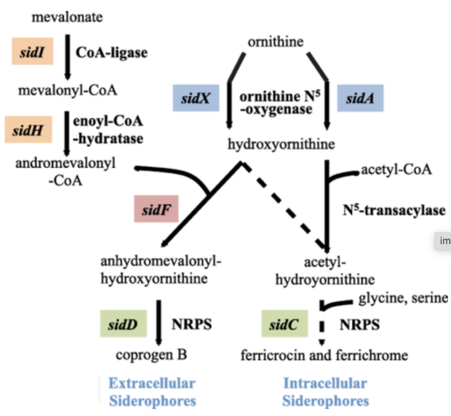
Figure1: Biochemical pathway (Plattner & Diekmann, 2020)

- Consider the table below demonstrating the ability of several strains of Talaromyces marneffei to synthesize coprogen B when cultured on various media. The ability to synthesize coprogen B is indicated by (+), while inability is indicated by (-). Using the figure you identified in (a) as a guiding tool, determine the gene mutated, if any, in each strain by placing the gene name in the last column of the table. 6 marks.

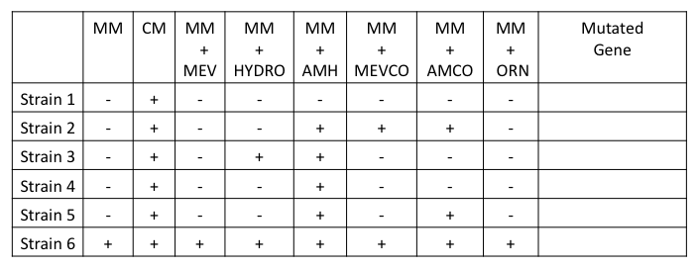
CYBB
- In 3-4 sentences (no more), explain why supplementing minimal media with Ornithine does not support the synthesis of coprogen B in strain 5. 2 marks.

A peptide bond usually links together two trans-fusarinine molecules to create a diketopiperazine unit (dimerumic acid) in Coprogen B. An ester linkage links together a third trans-fusarinine molecule. Failure to synthesize coprogen B in strain 5 might be related to the buildup of the lethal siderophore precursor N5 -acyl-N5 hydroxyornithine. Since there is no N-acetylation of the coprogen B, then there is no formation of coprogen.

Reference
Plattner, H. J., & Diekmann, H. (2020). Enzymology of siderophore biosynthesis in fungi. In Metal ions in fungi (pp. 99-116). CRC Press.

